**Module-2: GIT Assignment - 2**

1. Create a git working directory with feature1.txt and feature2.txt in the master branch.

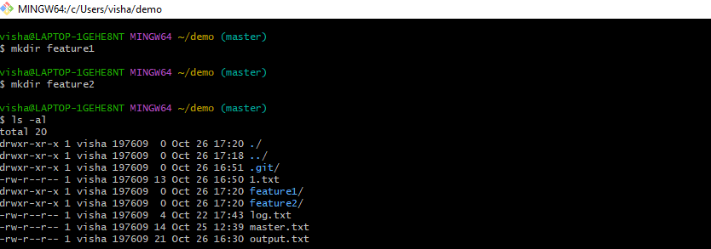

1. Create 3 branches develop, feature1 and feature2.

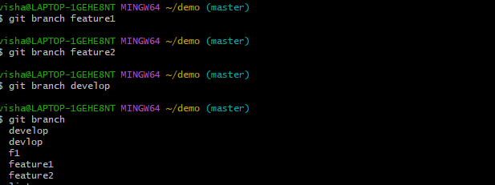

1. In develop branch create develop.txt, do not stage or commit it.

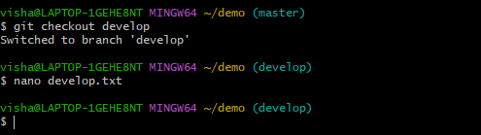

1. Stash this file, and checkout to feature1 branch.

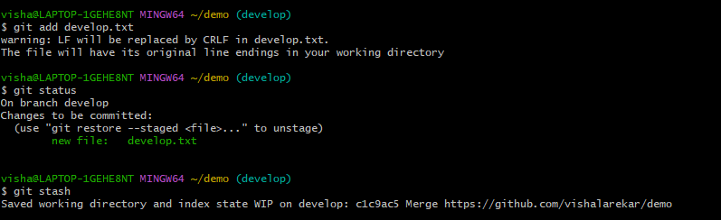

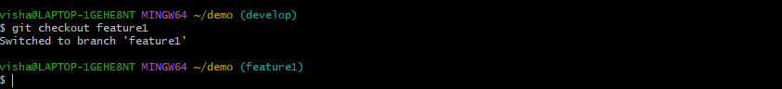

1. Create new.txt file in feature1 branch, stage and commit this file.

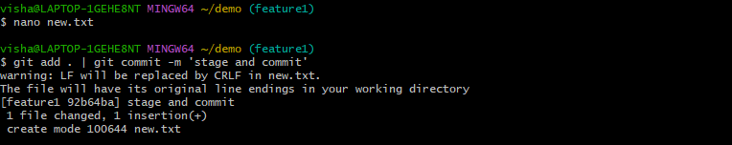

1. Checkout to develop, unstash this file and commit.

